1. 用液晶来显示数据

* 实验所需材料：

Arduino 2560、LCD液晶显示模块、超声波模块

* 连接示意图

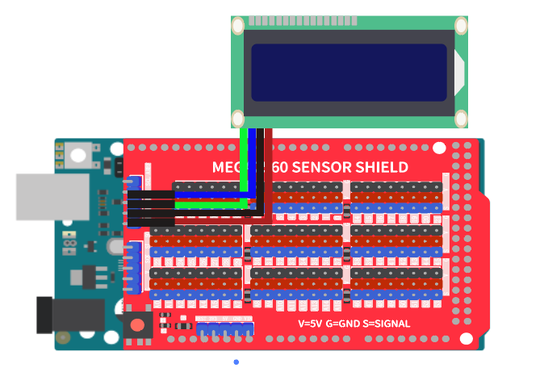

在之前的试验中，我们所有的数据都通过串口来进行显示，今天我们来通过液晶显示屏，显示一些数据

|  |
| --- |
| /*  OpenJumper LEDModule  www.openjumper.com  */  #include <Wire.h>  #include <LiquidCrystal_I2C.h>  LiquidCrystal_I2C mylcd(0x27,16,2);  void setup(){  mylcd.init();  mylcd.backlight();  }  void loop(){  mylcd.setCursor(0, 0);  mylcd.print("ni hao");  mylcd.setCursor(0, 1);  mylcd.print("hello world");  delay(1000);  mylcd.clear();  } |

接下来我们尝试将之前传感器模块的数据，来通过LCD液晶显示屏来显示

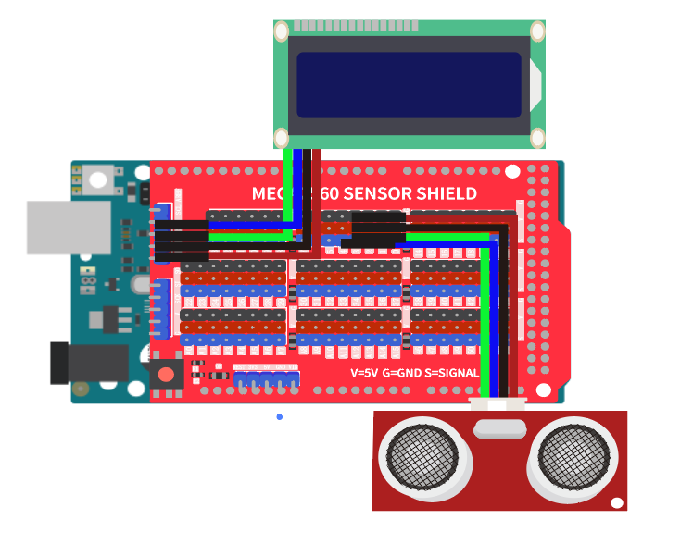

|  |
| --- |
| /*  OpenJumper LEDModule  www.openjumper.com  */  #include <Wire.h>  #include <LiquidCrystal_I2C.h>  volatile float dis;  LiquidCrystal_I2C mylcd(0x27,16,2);  float checkdistance_3_4() {  digitalWrite(3, LOW);  delayMicroseconds(2);  digitalWrite(3, HIGH);  delayMicroseconds(10);  digitalWrite(3, LOW);  float distance = pulseIn(4, HIGH) / 58.00;  delay(10);  return distance;  }  void setup(){  dis = 0;  pinMode(3, OUTPUT);  pinMode(4, INPUT);  mylcd.init();  mylcd.backlight();  }  void loop(){  dis = checkdistance_3_4();  mylcd.setCursor(0, 0);  mylcd.print("distance：");  mylcd.setCursor(0, 1);  mylcd.print(dis);  delay(1000);  mylcd.clear();  } |